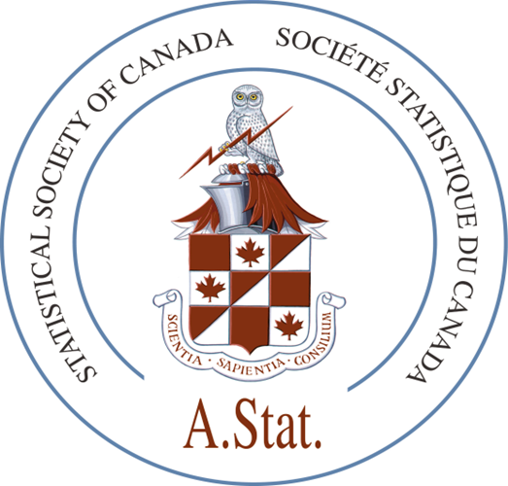

date

First name Last name
ASTAT# XXX
email

Dear First name,

The Accreditation Committee reviewed your application and brought a positive recommendation before the Board of the Statistical Society of Canada during its meeting on the 27th of March, 2022. The Board approved your application for accreditation as an Associate Statistician (A.Stat.) on this date. Congratulations!

After your annual membership fees and accreditation dues are paid you are permitted to affix your certification mark A.Stat. to your list of credentials after your name in written communications, an official certificate is sent via mail with the A.Stat. seal, and your professional summary and picture is published in the news section of the next issue of the Society’s newsletter Liaison. If you have not yet paid your annual SSC membership fee for 2022 then contact the Society’s office in Ottawa to arrange for this. All accreditation renewal dues in the first year of accreditation are payable at 100% for those accredited in January-April, at 50% for those accredited in May-September, and complimentary for those accredited in October-December. To submit your accreditation dues, contact the Society’s office as soon as possible. You indicate the details for your listing in the Public Directory of SSC Accredited Statisticians and the Accredited-only use searchable database on your Accreditation dues payment form. You are encouraged to upload a picture for photo identification.

SSC Accreditation requires A.Stat. members to be mentored by an accredited Professional Statistician (P.Stat.). Details of the mentorship program are available on the Society’s website. An Accredited member’s logon to the SSC website provides Accredited-only resources under My SSC. The Mentoring/Networking search option will help you find information about prospective mentors. A Mentoring Facilitator, Darcy Pickard, will assist you. (Note: If you forgot to logoff last time you were at the website, you need to logoff then logon to reach the Accredited-only resources.)

My SSC also provides Networking and Professional Development resources to augment your professional practice and assist you in your commitment to maintain professional competencies and an ethical statistical practice. A.Stat./P.Stat. members may use the Accreditation logo found in the Professional Development area for personal promotion such as on a website, business card, name plate, pen, and door/wall signage.
Please note that members maintain their accreditation qualification with the payment of annual membership fees and the annual accreditation dues in years of subsequent renewal. You will submit details about your professional practice and professional development activities annually on the renewal form.

Once again, congratulations on achieving this level of distinction of peer reviewed recognition of statistical training and demonstrating good oral and written communication skills in applied practice.

Cordially

Fabrice Larribe

Chair
Accreditation Committee

